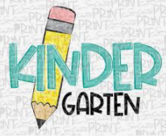Kindergarten Supply List

Sky View Elementary

(2) 18 ct. Crayola Crayons

(2) 10 ct. Crayola Washable Markers

(12) Plain Yellow 3-hole 2 pocket folders. **Please place them into 2’ binder.**

(12) Plain Blue 2 pocket folders with brads.

(30) Glue Sticks

( 2) or more Boxes of Kleenex

( 1) or more box(es) of Baby Wipes

( 6) Black Erase Markers (3 thin **and** 3 thick)

( 1) Children’s Scissors

2“ Plain White Binder **Please write your child’s name on it.**

3 doz. Clear Page Protectors

**Please choose One or More** of the following to donate for our playground equipment: Sand Toy, Sport’s Balls (**Soccer, Football, Nerf, Kickball, basketball, or rubber ball**)

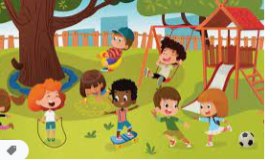

Optional this needed:

Sidewalk Chalk

Party Toys/dollar store toys/Mc Donald’s’ toys for treasure box

Small stuffed toys for reading incentives

Jump ropes

Ziplock Bags Gallon and snack preferred