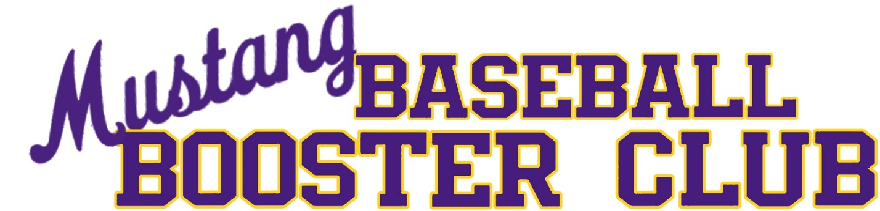
Meeting Minutes

Meeting Date: 8/20/2024
Meeting Time: 6:00 PM
Meeting Location: Sunrise Mountain HS Lecture Hall
Officers Present:
- Coach Michael Deardoff, Head Varsity Baseball Coach
- President – Natalie Dinnell
- Secretary – Jodi Ayala
- Treasurer – Elisabeth Escobar

The meeting was called to order at 6:20 pm.

- Treasurer’s Report
  - Balance as of 7/31/2024 $22,365.85
  - Total Deposits: $3,401.11 (May), $1,867.13 (June), $6,744.18 (July)
  - Total Withdrawals: $2,533.54 (May), $1,518.26 (June), $3,607.39 (July)
  - Purchase Breakdown: May-State Champion Shirts, Varsity lunch for state game, snack shack items. June-Snack Shack items, Hack Attack Service, Baseball pants invoice, summer shirts for freshman, mound clay for fields. July-Coaches shoes for 2025 season, engineering plans, steel, snack shack items.

- Follow-Up Items
  - The snack shack inventory has been updated in Square.
  - Fundraising numbers from last year: E-Team $11,316, Super Bowl Squares $1,100, Banner Sponsors $1,008.55, Best of the West Tournament $1,757, SW Airline Raffle $950, Summer Tournament Host $8,810, Kroger Rewards $379.75, Cleats Fan Shop $340, Snack Shack $6,669.31, Cash/Other Donations $3,775.
  - The plans for future booster club meetings will tentatively be the first Monday of every month, provided it is not a holiday. We would love for all parents to join these meetings and help make the program the best possible experience for the players.

- Upcoming needs/events:
  - Fall Tournaments and hosting schedule was provided by Coach Deardoff. Sept. 21-22, Sept. 28-29, Oct. 5-6
  - Coach Deardoff encouraged any players or families wanting to purchase fan gear to visit the Sunrise Mountain Baseball page to take advantage of the “at cost” pricing. There is no markup on these items. They are for everyone to enjoy and purchase at a reasonable price and support our teams. To purchase new gear, you can go to https://bsnteamsports.com/shop/BEATXf4mrs and to purchase gear from past seasons you can visit www.SunriseMountainBaseball.com.
  - For any parents that would like to get involved now, we always need help in the snack shack. There is a sign up sent out for events so please sign up if you can help. We would love to get more sponsorships for field banners this year, you can donate and receive tax credits for your donation.
  - The fridge in the snack shack is coming near the end of its life. If anyone is planning to get rid of their fridge or has a connection for a fridge, we would love to get connected to them. We do not anticipate the fridge making it to the end of this year. Last year, the current fridge housed the items in the snack shack which raised over $8600 for the program. This is an important item for our program so any help or connections to a fridge would be greatly appreciated.
  - This year we are planning an Alumni Day. Coach Deardoff discussed his ideas for the day and his vision. We would love to see any alumni and those who have gone on to play college ball. Coach Deardoff would like to retire a couple of jersey numbers for the players that went on to play professional ball. The Alumni Day will be January 4th and comparable the set up for family day last year, minus the dunk tank.
  - Taxes, District Forms and the Corporate Commission Renewal are due. The board members will be diligently working to have these completed and filed.

- Coach Needs/Updates
  - Coach Deardoff went over the tournament hosting schedule. He will need player help for the games Sept. 21-22, Sept. 28-29 and Oct. 5-6. He will have a sign-up sheet for the boys to help on these days. Last year, these tournaments brought in $8,399.66 for our program.
  - Coach Deardoff provided an update on the facilities plan. Upcoming plans include a shipping container structure behind home plate which will be used for storage and an announcer booth. Additionally, we are looking to upgrade the sound system at approximately 10K (Field 7K, 3k cages). The current system would be upgraded and speakers added to the cages. Coach has been working with the district to upgrade the backstop on the varsity field. The upgrade is anticipated to cost approximately $19,500. Bullpen upgrades would include installing turf. Refresh dugouts to include sandblasting the existing vinyl and repaint. The anticipated cost to sandblast the vinyl is $1650. A new scoreboard would be in the future and is anticipated to cost around 25K. The business advertisement on the scoreboard is up and a new business can purchase the ad space.
  - We will need to order two new banners this year.
  - The electrical outlets need to be repaired in the dugouts and cages.

Our next booster club meeting will be Monday, September 9th at 6 PM.
The meeting was adjourned at 7:00 pm.
Respectfully submitted by Jodi Ayala, Secretary

