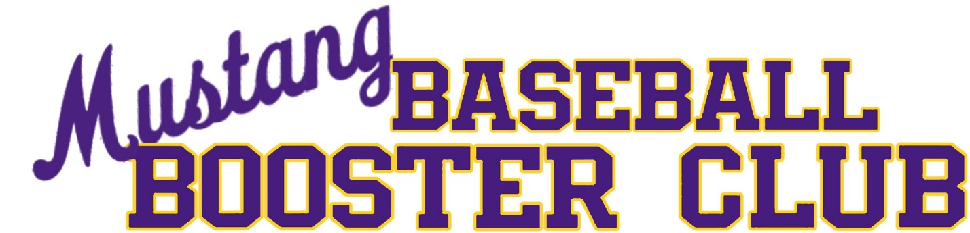
Meeting Minutes

Meeting Date: 1/6/2025
Meeting Time: 6:00 PM
Meeting Location: Sunrise Mountain HS Lecture Hall
Officers Present:
- Coach Michael Deardoff, Head Varsity Baseball Coach
- President – Natalie Dinnell
- Vice President – Shirlyn Cox
- Secretary – Jodi Ayala
- Treasurer – Elisabeth Escobar

The meeting was called to order at 5:58 pm.

- Treasurer’s Report
  - Balance as of 12/31/2024 $11,868.92
  - Total Deposits: $1,680.89
  - Total Withdrawals: $6,732.27
  - Purchase Breakdown: Winter ball umpire fees and uniforms (shirts) $1704, Alumni /Family Day prep (frames, activities) $1,797.01, Streaming Equipment (Mevo Camera) $378, Field Upgrades (dugouts/shipping containers) $1030, Miscellaneous – Adopt a Family, Coach Membership

- Follow-Up Items
  - Next year family day will be Saturday, December 20th. Time will be determined as we get closer to the event. Coach Deardoff would like everyone to save the date on their calendar. This years Family/Alumni Day was a huge success. The parent feedback on the event was very positive and many attendees complimented the alumni ceremony.
  - Natalie Dinnell has volunteered to request and coordinate the Gatorade delivery.
  - The next booster club meeting was changed from February 10th to February 18th at 6 PM. This date and time is tentative as it is based on Mr. Akins spring dates sports meeting schedule and more information will be forth coming.
  - Elisabeth Escobar volunteered to reach out to existing banner sponsors to see if they would like to renew their sponsorships. There is a form she will send out to the sponsors via email.
  - The mailbox is up for renewal. Natalie Dinnell will handle the renewal.
  - There are several banners in the team cart that need to be ordered and paid for. Coach Deardoff has a few more to add to the cart and will let the booster club know when those are ready.

- Upcoming needs/events:
  - Field Clean Up Day will not be needed this year on the varsity field. Coach Deardoff will connect with the Freshman team for a clean up day on the JV field. The date will be determined after tryouts.
  - The meeting attendees discussed and agreed to do the Super Bowl Squares fundraiser again this year. This information will be coming out via email. The deadline to purchase the squares will be February 5th. The booster board will make the square board on February 6th with the goal to send it out to all paid square purchasers on February 7th.
  - The meeting attendees discussed the need for team lunches on Wednesdays. It was determined we will not do team lunches this year on Wednesdays due to early release. All players will need to coordinate or bring their own meals on Wednesdays.
  - Each team will need a parent liaison to help coordinate team meals, etc. The parent liaison for each team will be determined at the next meeting in February.
  - Senior Day will be Tuesday, April 22nd. Mark your calendars!
  - The Banquet will be Monday, April 28th at 6:30 PM in the SMHS Cafeteria.
  - The next Booster Club meeting will tentatively be February 18th at 6 PM. This date and time is based on Mr. Akins spring dates sports meeting schedule and more information will be forth coming.

- Coach Needs/Updates
  - There will be games in Lake Havasu this year. Varsity will play in Havasu on April 9th. The Freshman and JV teams will play in Lake Havasu on April 7th.
  - Coach Deardoff requested a pelican case and base plugs.
  - We will be hosting a spring break tournament. The games will be Saturday through Wednesday during the week of spring break.
  - The spring break tournament will be 10 games at 1pm and 4pm.
  - For the spring break tournament, we will need volunteers for the admission table and snack shack.
  - Coach Deardoff provided an update on the field improvements. The containers have arrived. The varsity field netting will be done by this weekend. The sound system is complete and has been installed.
The meeting was adjourned at 7:05 pm.
Respectfully submitted by Jodi Ayala, Secretary

